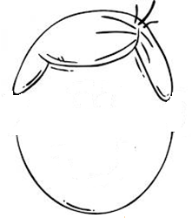
Sensible Sam

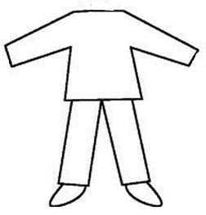

Note: It would be quite simple to follow this idea and cut the pieces to make your own Sensible Sam from large sheets of cardboard. He needs a big head to fit all of those wonderful sense organs!

